**FINANCIAL DATA ANALYSIS WITH PYTHON**

**SECTIONS:**

1. Introduction
2. Returns
3. Risk
4. Portfolio Allocation, and Optimization
5. Capital Asset Pricing Model
6. Simulations
7. Conclusion

**Section 1: Introduction, Acknowledgement:**

I have borrowed generously for this discussion from Finance365’s training on the same topic, and hosted on O’ Reilly Media website. The training, while addressing many preliminary issues pertaining to a balanced portfolio, does not dive deep or take any responsibility for ultimate decision making. In essence, it arms a buyer with handy information on reward risk ratios, and what to look for when assembling a basket.

It briefly glosses over how to simulate and optimally assign weights that result in a desirable outcome from one’s overall portfolio. Ultimately, a lot depends on one’s own risk tolerance, and investing goals. And so, with this in mind, how we use these tools varies by our own career goals, lifecycle consumption-savings plans, and strategic endeavors.

**Section 2: Returns**

Yahoo may well have lost its initial stature in the web-based industry from the early 2000’s. However, yahoo Finance still retains its clout. And is the medium even my finance professors used when demonstrating to us how to pick and pull stock information – ranging from daily closing price, to historical adjusted close prices.

Let us begin this discussion by looking at a popular Exchange Traded Fund. Now, for those of us who aren’t aware, ETF’s, while structured like Mutual Funds and tracking a given index, tend to trade like stocks, and update prices throughout the trading day. Mutual Funds meanwhile, update only at close time, and do not trade as frequently. This makes them good for buy and hold strategies. ETF also have the benefit of being tax exempt relative to Mutual Funds, and are thus good for higher frequency trading, than mutual funds.

The SPY ETF was one of the first I bought, during the economic downturn spurred by covid, with sufficient confidence in the market to rebound. Currently, what appears to some as markets soaring is really just the market recovering to pre-covid performance. So, without further ado, let us begin.

Figure 1 below depicts the simple daily returns of the SPY. The Widest ranges depict times during which prices were particularly volatile. Having plummeted on one end of the spectrum, and overcorrected the next, in due time reverting back to their mean.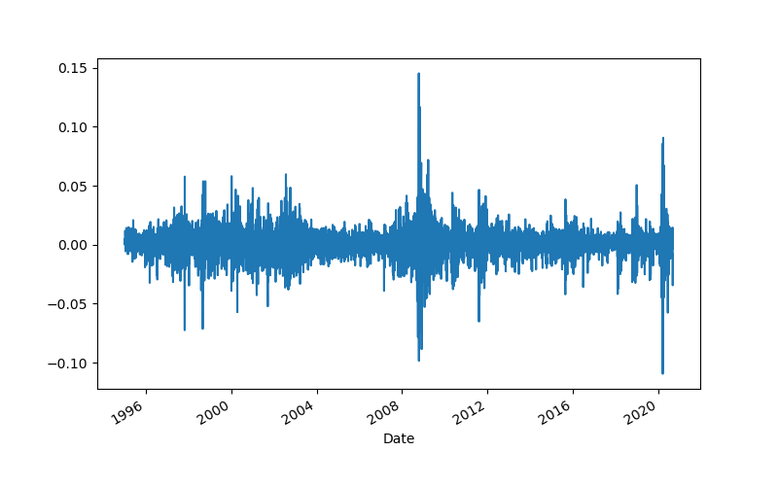

Figure 2, likewise, shows a smother graph of the same stock prices. In studying stock markets, we frequently apply the log transformation to more accurately trace the changes in a stock prices from one period to the next.

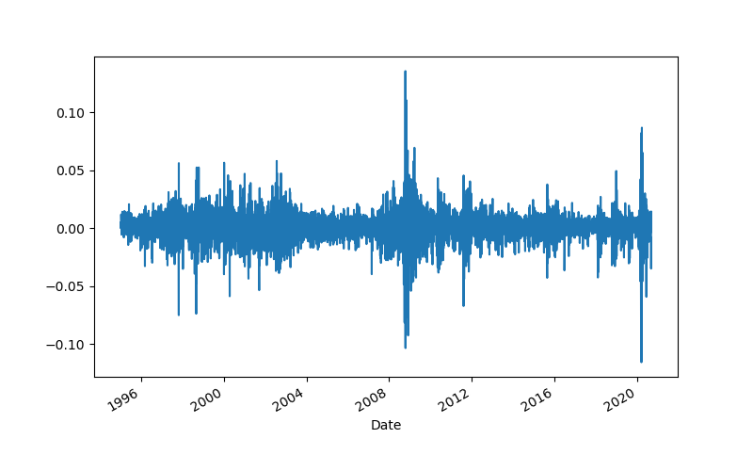

Of the numbers pictured below, the first shows us the daily log returns for SPY, pictured at less than a third of a percent. The next two, annualized first show the annual log returns to an investor holding shares of SPY, then express the same as a percentage – roughly 9.58% on average.

Figure 3: Log returns, SPY, annualized

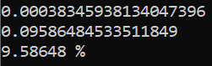

We extend our analysis to the 3 other ETF we hold and start to see a clearer picture of which shares return the most value, all else considered equal, or held constant. Printed below are the annualized means of QQQ, VOO, and IWF. The purpose of this exercise is not to talk about the parent company issuing the funds, or their rating. Rather it is to discuss what these comparative measures indicate about picking future stocks.

Figure 4: ETF mean annualized returns:

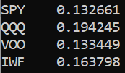

Following the mean, we naturally have the standard deviation. The yin to our yang, the good to our bad. By tempering our expectations, the standard deviation curbs our initial rection in jumping with joy at the QQQ’s returns. Note, in the following table that we’re also taking on added risk. And that in tying up more funds in this one share, we stand to see starker declines in our holdings.

Pictured below is a set of numbers that begins to get us thinking not only about the returns or rewards of a stock, which what most of us are concerned by, but the added risk involved in taking on an additional stock. And how it affects the balance of the overall portfolio.

Figure 5: The standard deviations of annualized stock prices

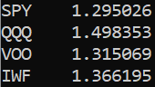

This captures the spirit of the reward risk ratio that so defines most of what we do with our finance. A quick glance shows that of the ETFs listed, the low risk low reward is epitomized in SPY, and high risk – high reward in the QQQs.

**Section 3: Risk**

Next, we move to directly examining risk. Of these, the most crucial are probably the covariance and correlation matrix, that determine how our overall portfolio will respond to adversity, or shocks.

From a cursory glance, we will notice that while covariances are low, correlations are high – meaning that while market adversities will not cause stocks in our basket to collectively plummet, boosts in market performance will cause our overall portfolio to soar collectively.

Figure 6: covariance matrix, annualized

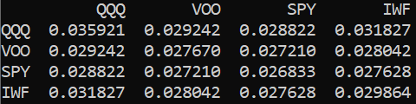

Figure 7: correlation matrix, daily returns

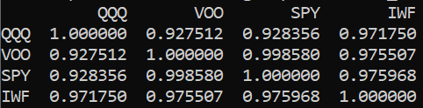

Figure 8: portfolio variance and volatility

The first metric in the output below is the portfolio variance, annualized. The next two are the standard deviation, or square root of the first metric. The following metrics for portfolio risk have been computed by assigning a 25% weight to each of 4 stocks held in this basket. And will vary with the weights assigned.

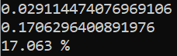

**Section 4: Allocation, Optimization**

Naturally, our inclination, even in everyday life, is to maximize our gains, while minimizing the risks that are a by-product of decision making, and course correcting. As the saying goes ‘no pain, no gain’. The pain here is the uncertainty associated with our investing decisions. Knowing where to draw the line is crucial to realizing our goals.

And now, probably one of the more fun aspects of portfolio analysis. Plotting and overlaying historical trends side by side. Below are the normalized returns, plotted on one graph.

Figure 9: normalized returns, comparative performance

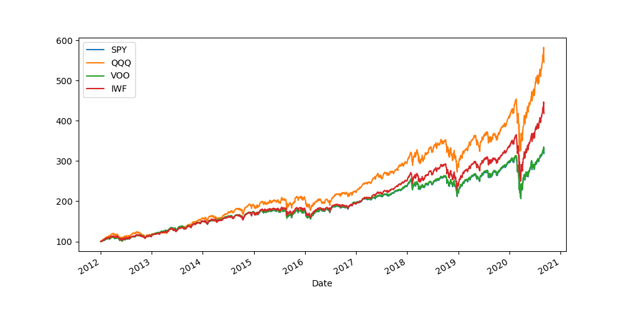

Figure 10: portfolio summary statistics

Putting together some crucial summary statistics, we need for generating the efficient frontier:

1. Mean
2. Covariance
3. Correlation

Remember, what matters when computing and assessing mean is not how the mean is calculated, or the covariance, or the correlation. But instead, how the underlying data is cut, normalized, subset, or aggregated – and how all the summary statistics depicted are context dependent and context reflective.

One again, repeats of previous computations reflect mean returns in the range of 13% to 19%, low covariance between stock pick, and high correlation. These are all promising indicators of a good basket.

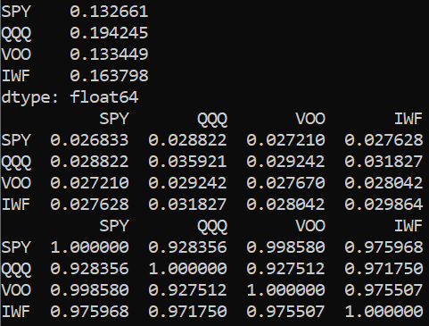

Now, we move into what can only be called the next step in portfolio allocation analysis. By simulating weights and plotting combinations of our stock basket with different weight allocations, we can better inform our balancing decisions. Refer below for a visualization of weight distributions for a 1000 simulations of portfolio weights, allocated to individual funds. We end up with return – volatility combinations as shown below. Plotting these combinations gives us the actual efficient frontier, we want to use to optimize our portfolio allocation decisions.

Figure 11: portfolio return vs. volatility: efficient frontier

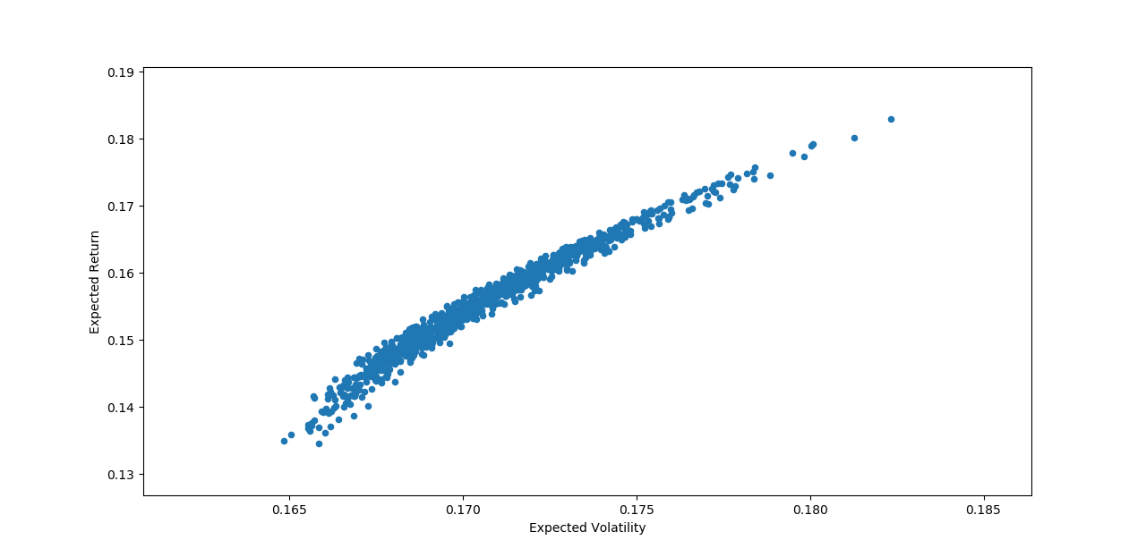

Figure 12: associated table for efficient frontier above

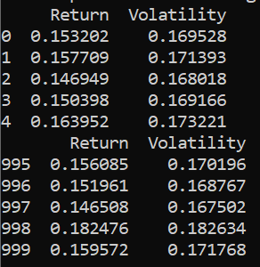

**Section 5: Capital Asset Pricing Model**

This next segment is restricted to the QQQ’s, and calculates and reports on the Sharpe ratio, as a measure of stock variation with respect to the market. In the interest of separating the wheat from the chaff, signal from the noise, and just trimming information – we are simply going report the following statistics, without delving into what a stock beta means, or what a Sharpe ratio really is. Though, these are the only two new concepts introduced, they don’t have much bearing on the rest of our analysis.

Figure 13: Capital Asset Pricing Model: Summary Statistics for Invesco QQQ

The metrics reported in the above picture, in order, are:

1. Covariance with market
2. Market variance
3. QQQ’s beta
4. QQQ’s expected return
5. Sharpe ratio

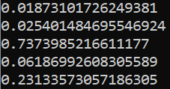

**Section 6: Simulation, Predicting Stock Price**

Now, in closing the discussion on investing, we address the stock we opened the discussion with, namely the SPY ETF. Shown below is it’s historical price trend over the last eight years.

Figure 14: SPY: historical price trend

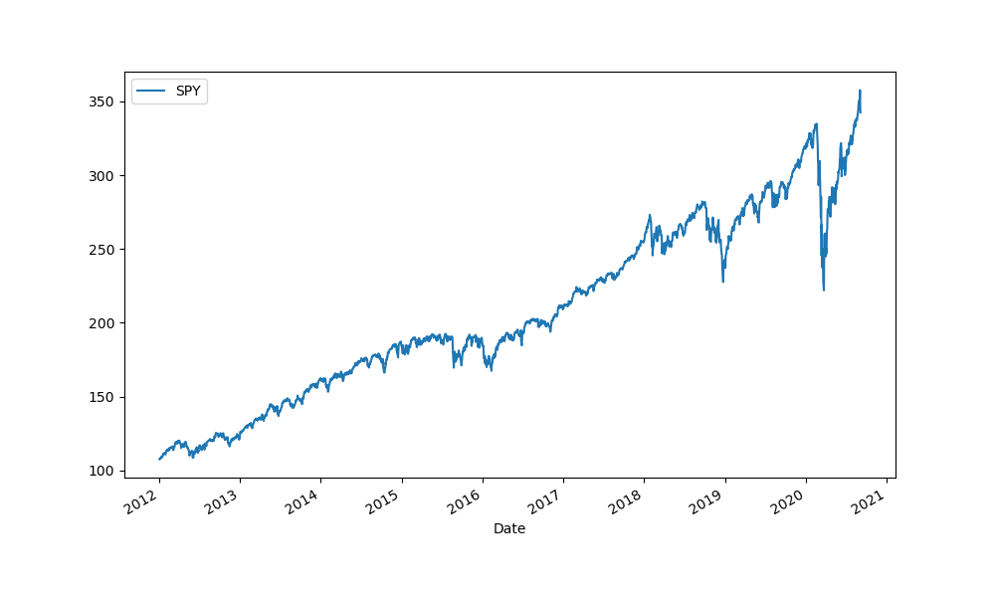

Additionally, we have the log returns, perfect for depicting price changes and fluctuations in the stock market.

Figure 15: Historical Log Returns: SPY

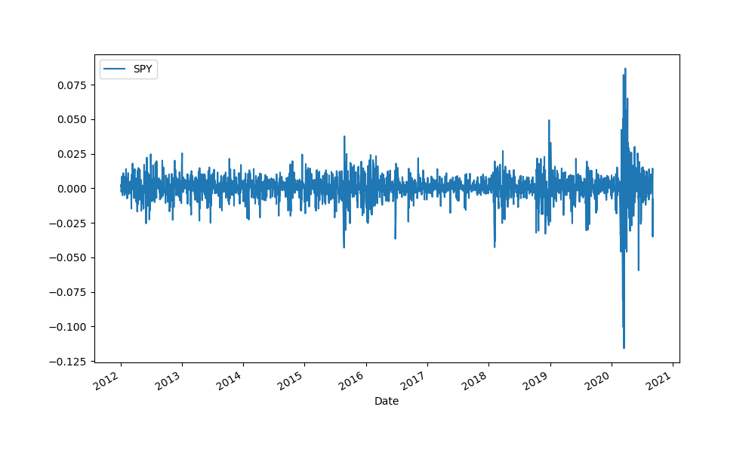

Finally, there is the added task of forecasting how stocks will perform in the upcoming period, and whether we should leave our money tied up in the current holdings, or if we should instead pivot to safer and better holdings. We now use our existing stock prices to predict the upcoming day’s stock prices for SPY

Figure 16: One-step ahead forecast: SPY



Lastly, in closing we do a multi step forecast, to see how stocks might perform set on multiple, various trajectories. To see this we run 10 iterations of the same model. And find, that while none perform drastically poorly, some perform better than other. The SPY tracking the S&P index is, for now, overall a safe investment, given my investment goals.

Figure 17: 10 Forecasts and simulations, based on historical trends in SPY stock price.

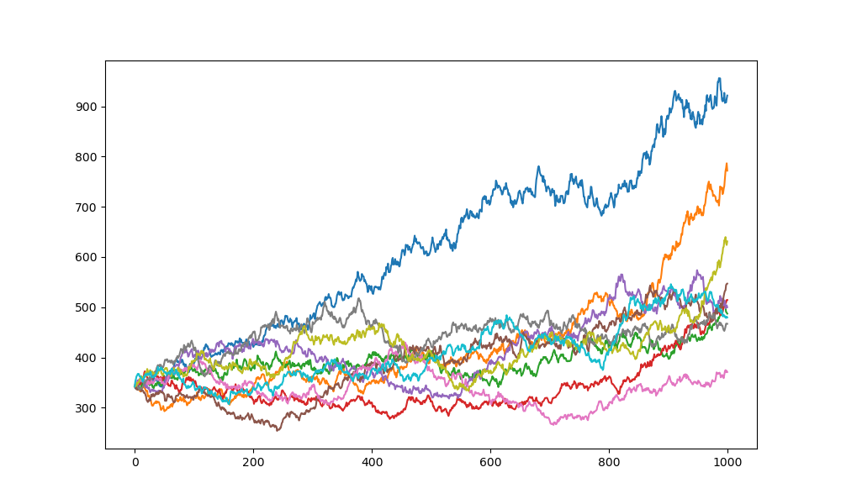

**Section 7: Conclusion**

In conclusion, what can be said about stock picking that can’t be said about other areas of life. Finances are a surprisingly emotional terrain. In recently acknowledging the same, behavioral finance experts have opened up a discussion of risk tolerance and level headedness. Rules of thumb to live by – don’t be rash, don’t be brash, take calculated risks, and don’t be smug when they payoff. Participating in the stock market can be a mighty lot of fun once you get the hang of it, and diversity prudently.

(Foot Note of absence: 29-30th August. Weekend dedicated to moving apartments.)